Standard Operating Procedure (SOP)
Implementing GitHub and Terraform for AWS Infrastructure Deployment

Document Information
Item | Value
SOP Name | GitHub & Terraform AWS Infrastructure Deployment
Version | 1.0
Owner | Cloud Engineering Team
Last Updated |  | July 2026

Audience | Cloud Engineers, DevOps Engineers, Platform Engineers

1. Purpose
This SOP describes the standardized process for provisioning, updating, and managing AWS infrastructure using Terraform with GitHub as the source control system and CI/CD platform.
Objectives include:
- Infrastructure as Code (IaC)
- Version control
- Peer-reviewed changes
- Automated deployments
- Repeatable infrastructure
- Auditability

2. Scope
Applies to:
- AWS Accounts
- Networking
- IAM
- EC2
- ECS
- EKS
- Lambda
- S3
- RDS
- Route53
- CloudFront
- Security Groups
- VPCs
- Terraform modules

3. Architecture
Developer

│

GitHub Repository
│
Pull Request
│
GitHub Actions
│
Terraform Init
Terraform Validate
Terraform Plan
│
Approval
│
Terraform Apply
│
AWS Infrastructure

4. Roles & Responsibilities
Role | Responsibility
Developer | Create infrastructure code
Reviewer | Review pull requests
DevOps Engineer | Maintain Terraform modules and pipelines
Cloud Administrator | AWS account management
Security Team | IAM and security reviews

5. Prerequisites

AWS
- AWS Organization
- AWS Account(s)
- IAM Roles
- OIDC Provider
- S3 Backend Bucket
- DynamoDB Lock Table

GitHub
- Organization
- Repository
- Branch Protection
- GitHub Actions enabled
- Repository Secrets

Local Tools
- Terraform
- AWS CLI
- Git
- VS Code (optional)

6. Repository Structure
terraform/

├── modules/
│ ├── vpc/
│ ├── ecs/
│ ├── rds/
│ ├── iam/
│ └── security_groups/
│
├── environments/
│ ├── dev/
│ ├── test/
│ ├── stage/
│ └── prod/
│
├── scripts/
├── .github/
│ └── workflows/
│
├── providers.tf
├── backend.tf
├── variables.tf
├── outputs.tf
└── versions.tf

GIT INSTALLATION PROCESS

Windows Installation

Step 1: Download Git
- Open your web browser.
- Go to https://git-scm.com/downloads.
- Click Download for Windows.

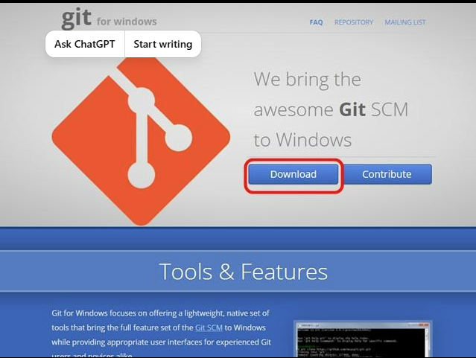

Step 2: Run the Installer
- Open the downloaded .exe file.
- Click Next through the installation wizard.
- Leave the default options unless your organization requires different settings.
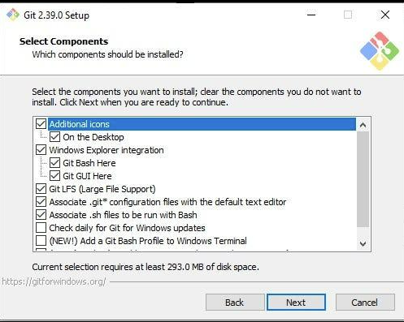

Step 3: Choose Your Editor
- Select your preferred text editor (Visual Studio Code is a common choice if installed).
- Click Next.

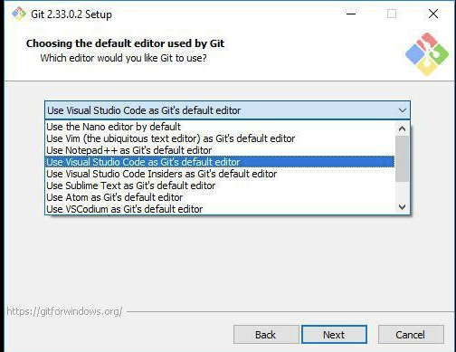

Step 4: Complete the Installation
- Click Install.
- After installation finishes, click Finish.

Step 5: Verify Installation
Open Command Prompt or PowerShell and run:
git --version
Expected output:
git version 2.xx.x.windows.x

macOS Installation

bash
brew install git
Alternative — Xcode Command Line Tools (no Homebrew needed):
bash
xcode-select --install
A popup will appear asking to install the tools — click Install, agree to the license, and wait for it to finish.
Verify either way:
bash
git --version

Linux
Debian/Ubuntu:
bash
sudo apt update
sudo apt install git
Fedora:
bash
sudo dnf install git
Arch:
bash
sudo pacman -S git
Verify:
bash
git --version

Linux:
The installation process may vary depending on your Linux distribution. Here are the commands for some common distributions:
- Debian/Ubuntu:
sudo apt update
sudo apt install git
- Fedora:
sudo dnf install git
- Arch Linux:
sudo pacman -S git
After running the appropriate command for your distribution, Git should be installed on your Linux system.
You can verify the installation on any platform by opening a terminal or command prompt and running:
git --version
This command will display the installed version of Git.
I hope these step-by-step instructions help you install Git on your preferred operating system. Let me know if you have any further questions!

Step 1: Create a New Repository

• Log in to GitHub.
• Click the + icon in the upper-right corner.
• Select New repository.
• Enter:
- Repository name
- Description (optional)
- Public or Private
• Optionally check:
- Add a README
- Add .gitignore
- Choose a license
• Click Create repository.
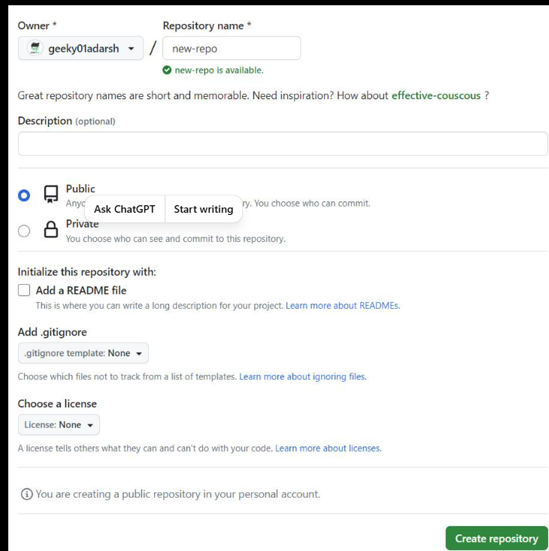

Step 2: Configure Repository Settings
- Open your repository.
- Click the Settings tab.
- Configure options such as:
  - Repository visibility
  - Branch protection rules
  - Collaborators
  - Secrets and variables
  - Actions permissions

Step 3: Copy the Repository URL
- Click the green Code button.
- Copy either:
  - HTTPS URL
  - SSH URL
Example:
https://github.com/your-username/your-repository.git

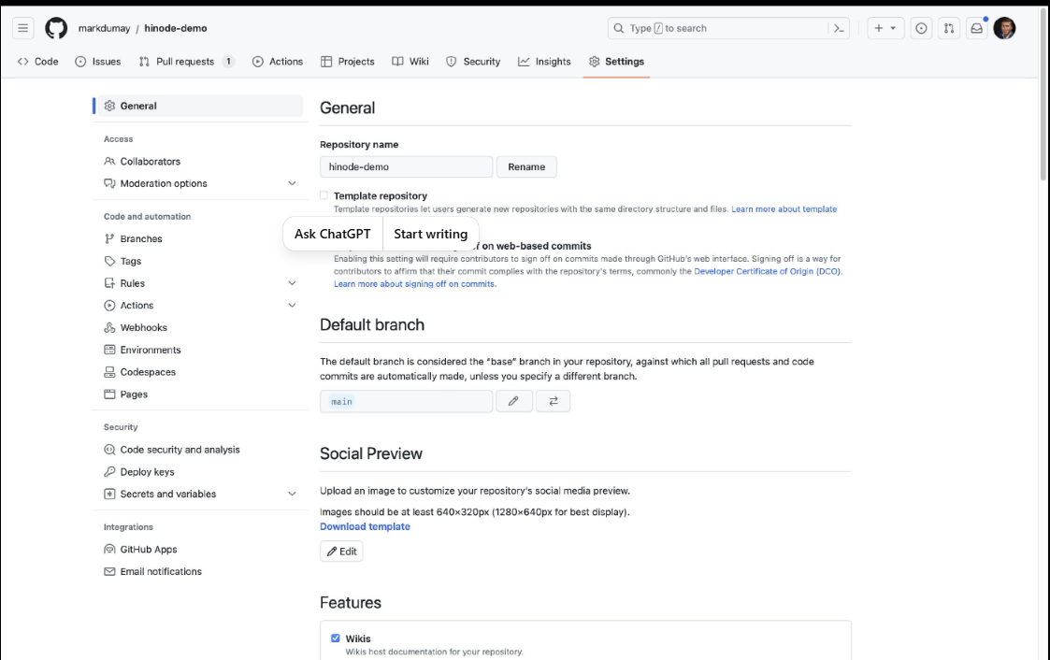

Step 3: Copy the Repository URL
- Click the green Code button.
- Copy either:
  - HTTPS URL
  - SSH URL
Example:
https://github.com/your-username/your-repository.git

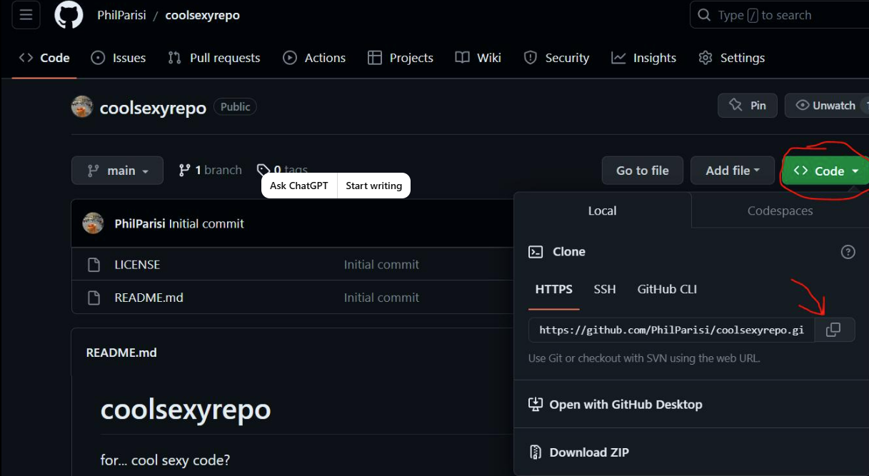

Step 4: Connect Your Local Project
Open a terminal:
git init
git add .
git commit -m "Initial commit"
git branch -M main
git remote add origin https://github.com/your-username/your-repository.git
git push -u origin main

Step 5: Authenticate
If prompted:
- Sign in through your browser, or
- Use a Personal Access Token (PAT) instead of your GitHub password when using HTTPS.

7 Branch Strategy
Branch | Purpose
main | Production
develop | Development
feature/* | New features
hotfix/* | Emergency fixes
Rules
- Direct commits to main prohibited
- Pull Request required
- Two approvals required
- CI checks must pass

Configure Terraform and Setup Workflows

1. Put your Terraform code in a Git repo
Initialize a repo in your Terraform project directory:
bash
cd my-terraform-project
git init
git add .
git commit -m "Initial Terraform configuration"
Then connect it to a remote (GitHub, GitLab, etc.):
bash
git remote add origin https://github.com/you/my-terraform-project.git
git push -u origin main

2. Add a .gitignore (this part is critical)
Terraform generates files you should never commit — especially state files, which can contain secrets in plaintext. Create a .gitignore:
gitignore
# Local .terraform directories
**/.terraform/*
# State files
*.tfstate
*.tfstate.*

# Crash logs
crash.log
crash.*.log

# Variable files with secrets
*.tfvars
*.tfvars.json

# Override files
override.tf
override.tf.json
*_override.tf
*_override.tf.json

# Plan output files
*.tfplan

# Lock file is usually KEPT (see below)
Note: .terraform.lock.hcl should be committed — it pins provider versions for reproducibility. Don't ignore it.

4. Handle secrets outside Git
Never commit real values in .tfvars. Options:
- Environment variables: export TF_VAR_db_password="..."
- A secrets manager (AWS Secrets Manager, Vault, etc.) referenced via data sources
- CI/CD secret storage (GitHub Actions secrets, GitLab CI variables)

5. Automate with CI/CD (the real "integration")
This is where Terraform + Git becomes powerful. A typical GitHub Actions workflow runs plan onyaml
name: Terraform
on:
pull_request:
push:
branches: [main]

jobs:
terraform:
runs-on: ubuntu-latest
steps:
- uses: actions/checkout@v4

- uses: hashicorp/setup-terraform@v3

- name: Terraform Init
run: terraform init

- name: Terraform Format Check
run: terraform fmt -check

- name: Terraform Validate
run: terraform validate

- name: Terraform Plan
run: terraform plan -no-color
# on PRs this shows what would change

- name: Terraform Apply
if: github.ref == 'refs/heads/main' && github.event_name == 'push'
run: terraform apply -auto-approve
pull requests and apply on merge to main:

8. Terraform Backend Configuration
Remote state stored in:
- S3 Bucket
- DynamoDB table for state locking
Example:
terraform {

backend "s3" {

bucket = "company-terraform-state"

key = "network/dev.tfstate"

region = "us-east-1"

dynamodb_table = "terraform-locks"

encrypt = true

}

}

9. Development Workflow

Step 1
Create Feature Branch
git checkout develop

git pull

git checkout -b feature/create-vpc

Step 2
Develop Terraform Code
Example:
- Create module
- Update variables
- Update outputs

Step 3
Validate
terraform fmt

terraform validate

Step 4
Plan
terraform plan
Review output.

Step 5
Commit
git add .

git commit -m "Create VPC module"

git push

Step 6
Create Pull Request
PR should include:
- Purpose
- Resources added
- Resources removed
- Risks
- Rollback plan

Step 7
Code Review
Reviewer checks:
- Naming conventions
- Security
- Tags
- Variables
- Module usage
- Outputs
- Least privilege

Step 8
Merge
Merge into:
- develop
- main (production)

10. GitHub Actions Workflow
Pipeline
Checkout Code

↓

Terraform Init

↓

Terraform Format

↓

Terraform Validate

↓

Terraform Plan

↓

Approval

↓

Terraform Apply

11. Deployment Process
Development
Merge

↓

Auto Apply
Production
Merge

↓

Terraform Plan

↓

Manual Approval

↓

Terraform Apply

12. Secrets Management
Never store:
- AWS Keys
- Passwords
- Tokens
- Certificates
Use:
- GitHub Secrets
- AWS Secrets Manager
- AWS SSM Parameter Store

13. Security Standards
Use:
- OIDC authentication

Create the OIDC identity provider (AWS Console)
1. Sign in to the AWS Console with an account that has IAM admin permissions.
2. Go to IAM (search "IAM" in the top search bar).
3. In the left sidebar, click Identity providers.
Click Add provider (top right).
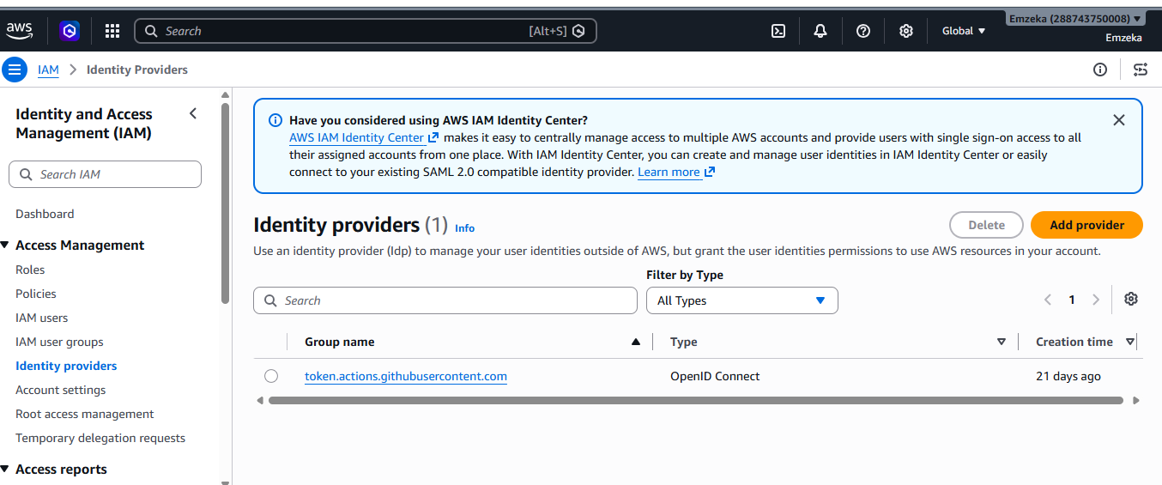

- Under Provider type, select OpenID Connect.
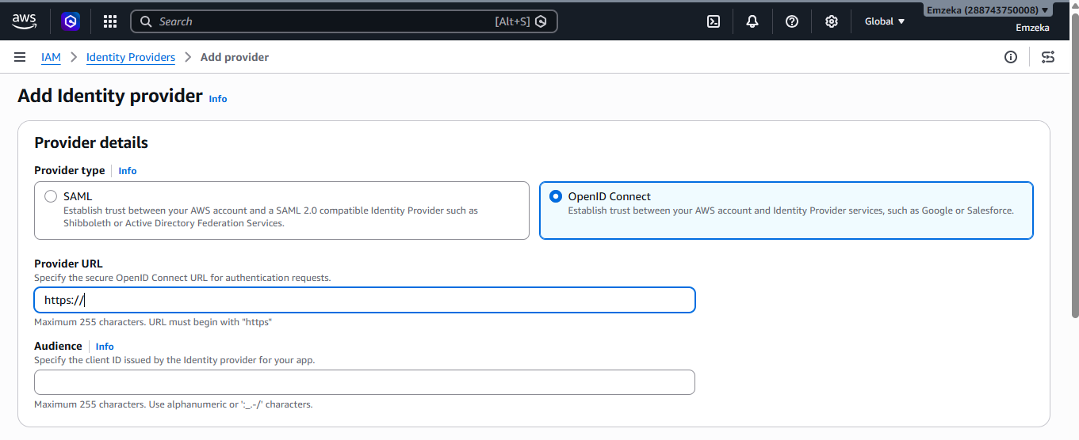
6. In Provider URL, enter:
https://token.actions.githubusercontent.com

- IAM Roles
- Least privilege
- Remote state encryption
- State locking
- Module versioning
Never:
- Commit tfstate
- Commit credentials
- Disable encryption

14. Rollback Procedure
If deployment fails:
- Stop pipeline
- Review Terraform Plan
- Restore previous commit
- Create rollback PR
- Merge
- Terraform Apply

15. Disaster Recovery
State corruption
- Restore S3 version
- Unlock DynamoDB if required
- Re-run Terraform Plan
- Verify resources

16. Best Practices
✔ Reusable modules
✔ Small pull requests
✔ Mandatory code reviews
✔ Version pinning
✔ Consistent tagging
✔ Environment isolation
✔ Separate state files
✔ Least privilege IAM
✔ Remote backend
✔ Automated validation
✔ Policy checks (e.g., Checkov or tfsec)

17. Common Commands
terraform init

terraform fmt

terraform validate

terraform plan

terraform apply

terraform destroy

terraform state list

terraform output

18. Troubleshooting
Issue | Resolution
State lock | Remove stale lock after verification
Provider mismatch | Run terraform init -upgrade
Plan differs unexpectedly | Refresh state and review drift
Access denied | Verify IAM role and OIDC trust policy
Backend unavailable | Check S3 bucket and DynamoDB table

19. Change Management
Every infrastructure change must include:
- GitHub Issue or change request
- Feature branch
- Pull Request
- Successful CI validation
- Required approvals
- Terraform Plan review
- Post-deployment verification

20. References
- Terraform documentation
- AWS Well-Architected Framework
- GitHub Actions documentation
- AWS IAM best practices

Recommendations
To make this SOP enterprise-ready, consider adding appendices with:
- A GitHub Actions workflow (terraform-plan.yml and terraform-apply.yml).
- Sample Terraform configurations for the S3 backend, provider, and reusable modules.
- AWS IAM/OIDC setup for GitHub Actions.
- Environment promotion flow (Dev → Test → Stage → Prod).
- Governance controls such as mandatory tagging, policy-as-code (e.g., Checkov), and approval gates.
- Architecture diagrams illustrating the deployment flow, Terraform state management, and GitHub Actions authentication to AWS. These additions make the SOP suitable as both an operational guide and onboarding document.

